**SOLANO COMMUNITY COLLEGE**

**MT 162, ROBOTICS**

Fall, 2018

SOLANO COMMUNITY COLLEGE

ROBOTIC SYSTEMS MT-162

**LAB 13: Palletizing and Program Adjust**

**Catharine Crayne**

12/10/18

**OBJECTIVE**:

1. To create a motion program that will palletize a set of wood blocks.
2. Perform a Program Adjustment to a program running in Auto

**GROUP MEMBERS**

*Dianne Halsey, Jerry Livingston, Alex, Joel*

**MATERIALS**: RoboGuide and Laptop, Fanuc Robot

**PROCEDURE**:

**Palletizing**

1. Create a motion program that will pick up 6 or more arranged Jenga type blocks (single layer) and then palletize them at a different location. The palletizing should be 3 wide and then the next layer 3 wide but 90 degrees to the previous layer.
2. You may need to add additional motions to keep the blocks arranged.
3. Incorporate the use of offset to achieve the second layer of the pallet.
4. Incorporate some logic and incrementing registers to keep the program simplified.
5. Verify that it works. Save a copy of your program.

**Program Adjust:**

1. During the Auto run of the above program, press EDIT and LOOK to investigate where the program is during Auto.
2. Select the Prog Adjust Menu from the main MENU under UTILITIES and [TYPE].
3. Move the cursor to an unused schedule and press [DETAIL] and enter the range of line numbers that correspond with motion instructions of your program.
4. Adjust the entire movement 25 mm to the left of the robot, 25 mm away from the robot, and rotated 20 degrees. ENABLE the adjustment and verify it works during the next cycle.
5. Now adjust the linear speed to a slower value. ENABLE the adjustment and verify it.
6. Disable all Program Adjustments from the Prog. Adjust Menu.

**RESULTS - DATA**

Not applicable for this lab

**OBSERVATIONS**

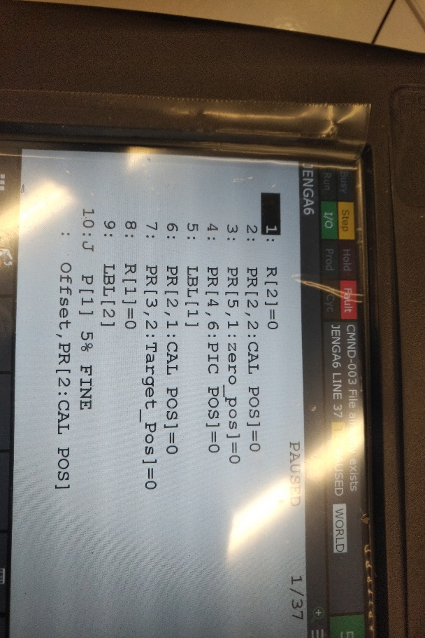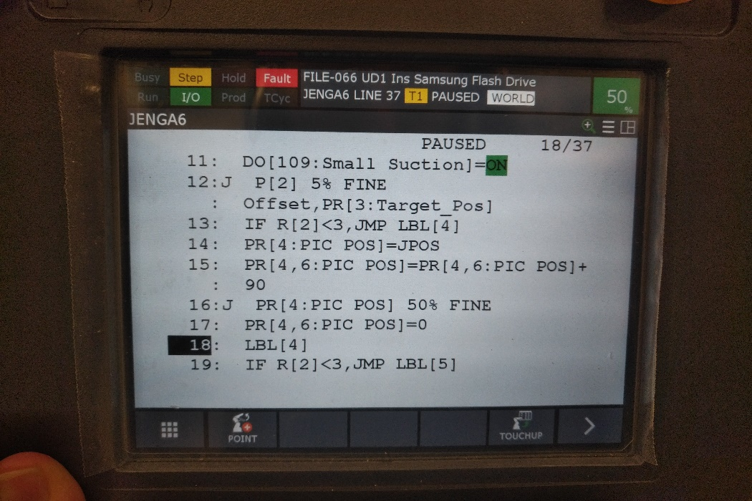

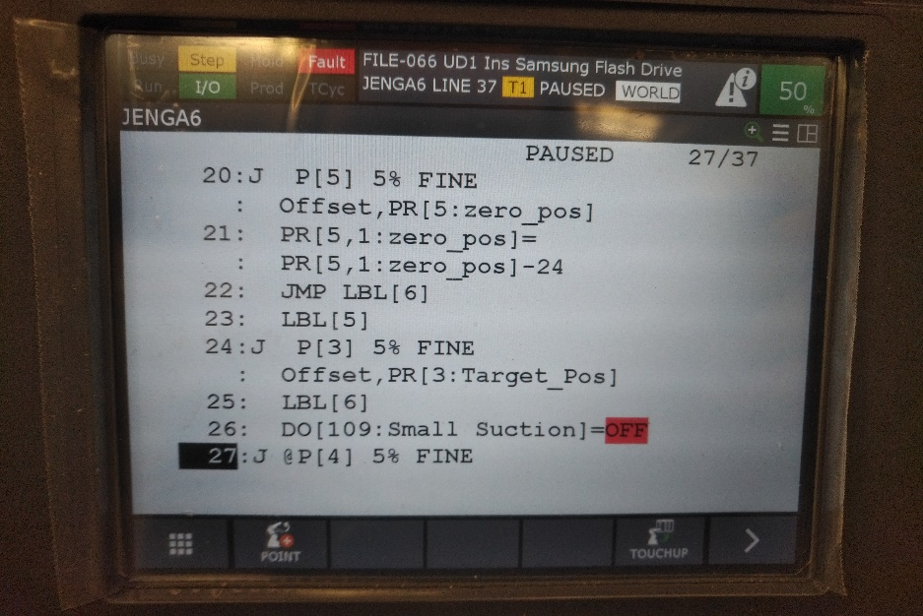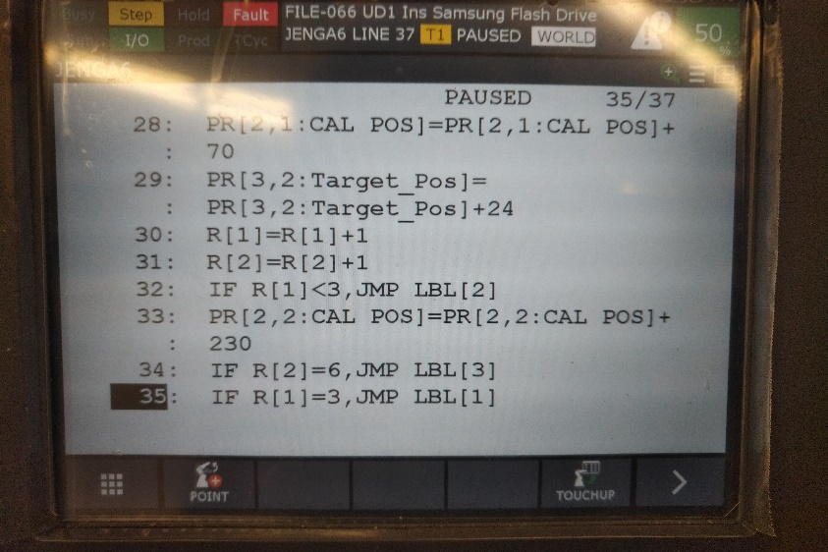

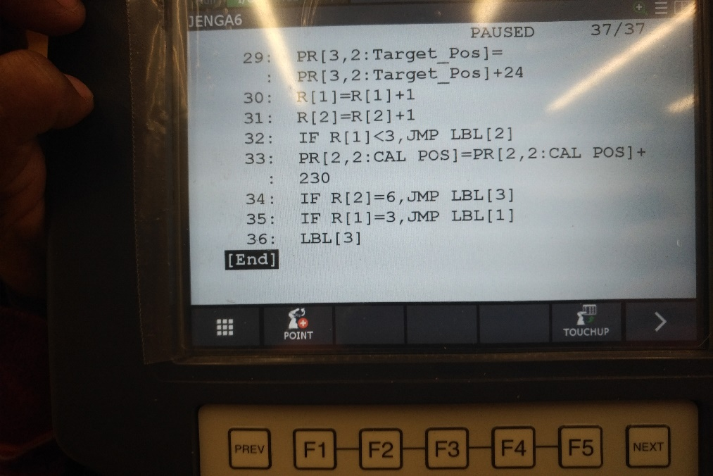

**Program Text**

/PROG  JENGA6

/ATTR

OWNER        = MNEDITOR;

COMMENT        = "";

PROG_SIZE    = 1293;

CREATE        = DATE 18-11-29  TIME 20:57:06;

MODIFIED    = DATE 18-12-04  TIME 21:33:42;

FILE_NAME    = ;

VERSION        = 0;

LINE_COUNT    = 36;

MEMORY_SIZE    = 1781;

PROTECT        = READ_WRITE;

TCD:  STACK_SIZE    = 0,

     TASK_PRIORITY    = 50,

     TIME_SLICE    = 0,

     BUSY_LAMP_OFF    = 0,

     ABORT_REQUEST    = 0,

     PAUSE_REQUEST    = 0;

DEFAULT_GROUP    = 1,*,*,*,*;

CONTROL_CODE    = 00000000 00000000;

/MN

  1: R[2]=0    ;

  2: PR[2,2]=0    ;

  3: PR[5,1]=0    ;

  4: PR[4,6]=0    ;

  5: LBL[1] ;

  6: PR[2,1]=0    ;

  7: PR[3,2]=0    ;

  8: R[1]=0    ;

  9: LBL[2] ;

 10:J P[1] 5% FINE Offset,PR[2]    ;

 11:  DO[109]=ON ;

 12:J P[2] 5% FINE Offset,PR[3]    ;

 13:  IF R[2]<3,JMP LBL[4] ;

 14:  PR[4]=JPOS    ;

 15:  PR[4,6]=PR[4,6]+90    ;

 16:J PR[4] 50% FINE    ;

 17:  PR[4,6]=0    ;

 18:  LBL[4] ;

 19:  IF R[2]<3,JMP LBL[5] ;

 20:J P[5] 5% FINE Offset,PR[5]    ;

 21:  PR[5,1]=PR[5,1]-24    ;

 22:  JMP LBL[6] ;

 23:  LBL[5] ;

 24:J P[3] 5% FINE Offset,PR[3]    ;

 25:  LBL[6] ;

 26:  DO[109]=OFF ;

 27:J P[4] 5% FINE    ;

 28:  PR[2,1]=PR[2,1]+70    ;

 29:  PR[3,2]=PR[3,2]+24    ;

 30:  R[1]=R[1]+1    ;

 31:  R[2]=R[2]+1    ;

 32:  IF R[1]<3,JMP LBL[2] ;

 33:  PR[2,2]=PR[2,2]+230    ;

 34:  IF R[2]=6,JMP LBL[3] ;

 35:  IF R[1]=3,JMP LBL[1] ;

 36:  LBL[3] ;

/POS

P[1]{

  GP1:

    UF : 0, UT : 1,        CONFIG : 'N U T, 0, 0, 0',

    X =   379.819  mm,    Y =  -112.353  mm,    Z =  -316.981  mm,

    W =  -179.874 deg,    P =     -.329 deg,    R =     2.324 deg

};

P[2]{

  GP1:

    UF : 0, UT : 1,        CONFIG : 'N U T, 0, 0, 0',

    X =   270.153  mm,    Y =   -26.129  mm,    Z =  -220.723  mm,

    W =  -178.748 deg,    P =     -.366 deg,    R =     2.317 deg

};

P[3]{

  GP1:

    UF : 0, UT : 1,        CONFIG : 'N U T, 0, 0, 0',

    X =   402.343  mm,    Y =   -16.284  mm,    Z =  -318.268  mm,

    W =  -178.749 deg,    P =     -.369 deg,    R =     2.316 deg

};

P[4]{

  GP1:

    UF : 0, UT : 1,        CONFIG : 'N U T, 0, 0, 0',

    X =   401.280  mm,    Y =   -20.484  mm,    Z =  -128.972  mm,

    W =  -178.749 deg,    P =     -.366 deg,    R =     2.313 deg

};

P[5]{

  GP1:

    UF : 0, UT : 1,        CONFIG : 'N U T, 0, 0, 0',

    X =   405.520  mm,    Y =    19.459 mm,    Z =  -297.951  mm,

    W =   179.634 deg,    P =    -1.252 deg,    R =    92.325 deg

};

/END

**Analysis Questions:**

1. Why are robots often used for palletizing?

*Robots make the palletizing process more efficient. Robots won’t hurt their back and sue you.*

1. What type of gripper is often used with palletizing operations? Why?

*Hydraulic grippers are often used with palletizing operations because they have the most strength. However, pneumatic grippers can be used if the load being moved is relatively light. Pneumatic grippers can be used in clean room applications, while hydraulic grippers cannot.*

1. When using the Program Adjust utility, which frames can the changes be made to?

*USER and TOOL frames*

1. When doing a program linear speed adjustment like in step 10, do all motions now move at the new speed? How do you know?

*Yes, visual observation.*